

Click here to enter text.

Click here to enter text.

*Geophysical Survey & Logistics Report*

Click here to enter text.

Table of Contents

Introduction 3

Personnel 5

Equipment 5

Survey Methods 6

Data Acquisition Parameters 8

Production Summary 9

List of Figures

Figure 1: General transmitter loop and survey lines map. 4

Figure 2: Standard channel configurations. 6

Figure 3: Standard Crone Pulse-EM waveform. 7

List of Tables

Table 1: Surface Survey Transmitter Loop Coverage. The northern edge of the loop was moved approximately 40m to accomodate lines 1200N and 1250N. 8

Table 2: Surface Survey Coverage 8

Table 3: Channel configuration for the 16.66ms timebase using 20 channels. 9

Table 6: Production Summary. 9

List of Appendices

Appendix 1: Plan maps 1

Appendix 2: Linear-scale Pulse-EM data profiles 2

Appendix 3: Step response data profiles 3

# Introduction

Crone Geophysics & Exploration Limited was contracted by Click here to enter text. to conduct Click here to enter text. on its Click here to enter text. located in Click here to enter text.. This report summarizes the geophysical work carried out through Click here to enter text..

Click here to enter text. surface lines utilizing Click here to enter text. transmitter loops were surveyed during this period. The appendices to this report contain page size plan maps, linear- and logarithmic-scale data profiles, and step response profiles.

A surface line and transmitter loop location map is presented in Figure 1.

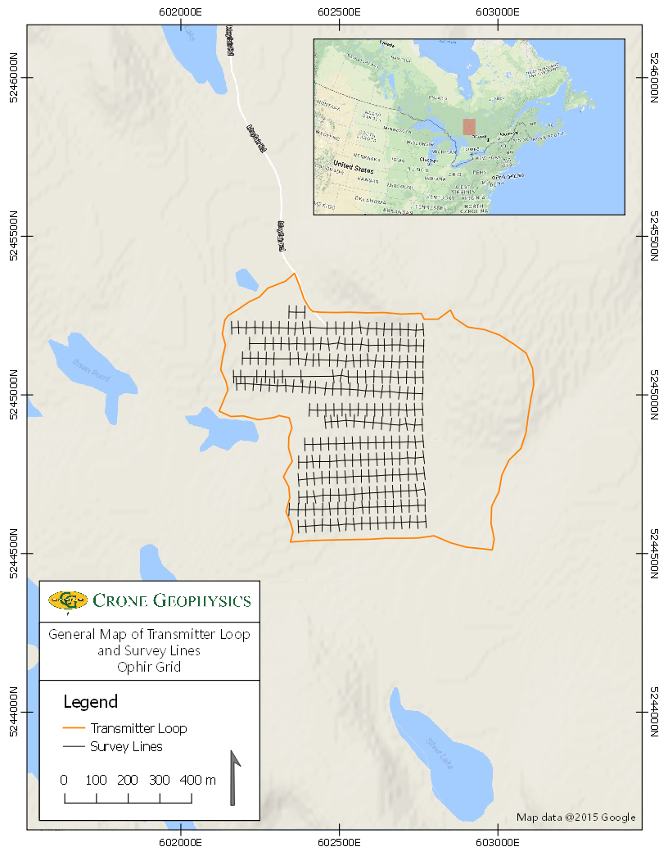

Figure 1: General transmitter loop and survey lines map.

# Personnel

The personnel involved in this project during the reporting period include:

Survey Operator: Click here to enter text.

Data Processing: Click here to enter text.

Report: Eric Meunier

# Equipment

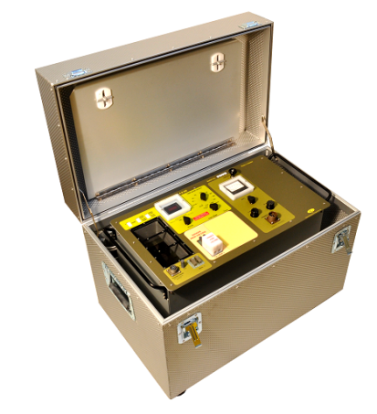

**Pulse-EM Transmitter**

* 4.8kW for up to 30 amps in single or 60 amps in dual modes
* Timebases: 8.33ms to 2000ms
* Ramp Settings: Fast Ramp, 0.5ms, 1.0ms or 1.5ms
* Powered by standard motor generator
* Current control and monitoring with optional loop damping
* 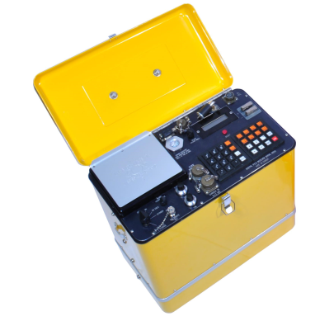Auto Shutdown and grounded case for safety

**Pulse-EM CDR2 Receiver**

* 26-Bit equivalent A/D resolution
* Programmable gate configurations and optional full waveform
* Crone *Smartstacking* algorithm
* Sampling Rate: 250K samples/second | Sampling Interval: 4μsec
* Precision crystal oscillator or cable synchronization

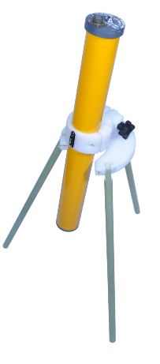**Pulse-EM Surface Coil**

* Ferrite cored antenna with preamplifier
* Bandwidth: 10kHz
* Effective coil area: 4000m2
* Amplifier gain: 25
* Spirit levels for coil alignment
* Two 9-volt DC battery power supply

# Survey Methods

Crone Pulse-EM is a time domain electromagnetic method in which a precise pulse of current with a controlled linear shut off is transmitted through a large loop of wire on the ground and the rate of decay (dB/dt) of the induced secondary field is measured across a series of time windows during the off-time. The electromotive force (EMF) created by the sudden turn-off of the current induces eddy currents in nearby conductive material, generating a secondary electromagnetic field. When the primary field is terminated, this electromagnetic field will decay with time. The amplitude of the secondary field and the decay rate are dependent on the quality and size of the conductor.

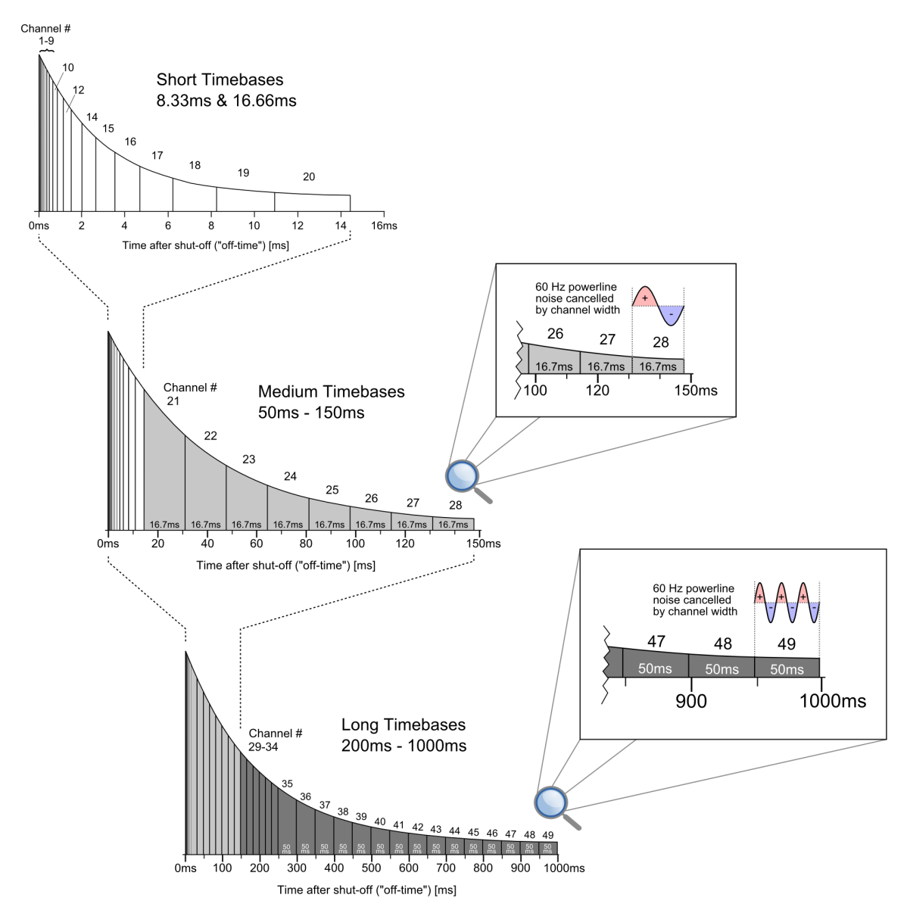

Figure 2: Standard channel configurations.

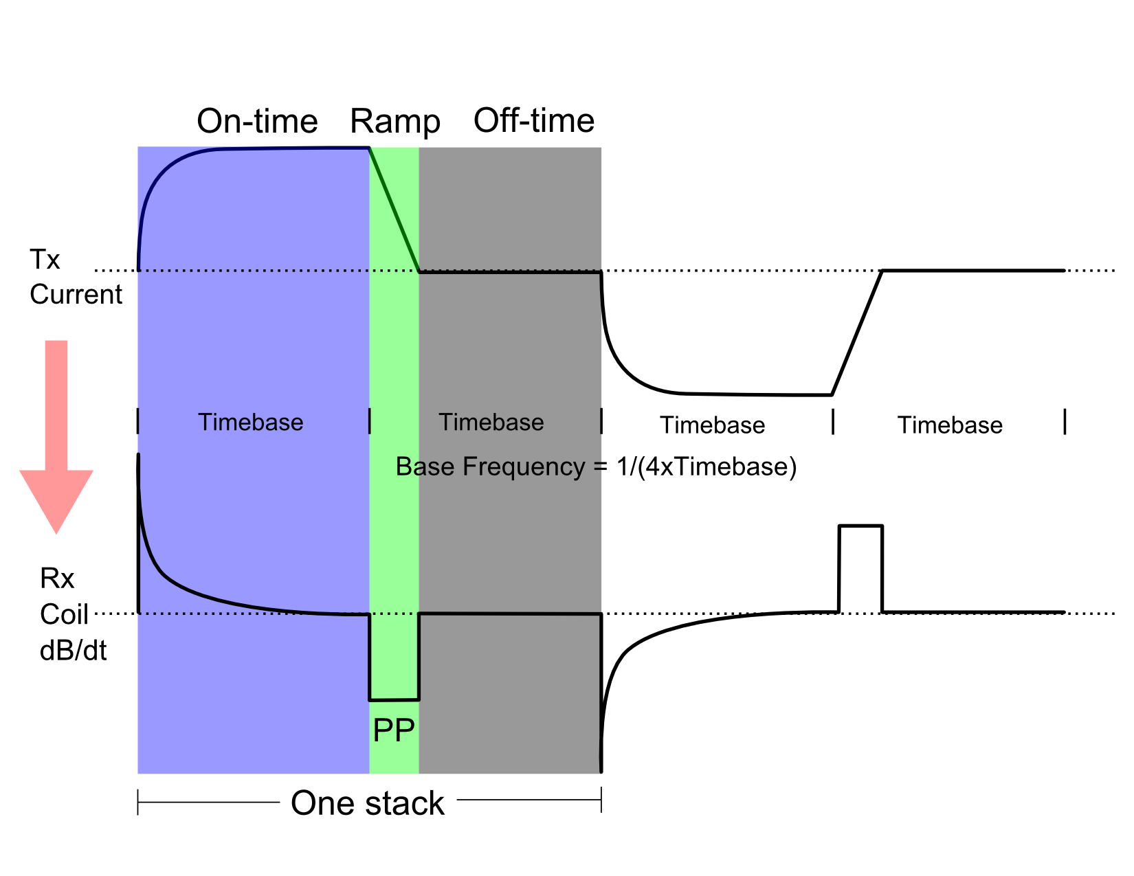

Figure 3: Standard Crone Pulse-EM waveform.

In addition to measuring the standard Primary Pulse channel in the Tx shut-off ramp and the off-time channels, the Step Response was also calculated. Step Response requires accurate geometrical control in which the loop position and Choose an item. are accurately determined. Positional information was collected using a sub-meter capable GPS, and is provided in the UTM Zone Click here to enter text. coordinate system utilizing the Click here to enter text. datum. The Step Response is widely regarded as a very important tool in the search for high conductance massive sulphides.

The calculated Step Response values are binned into an S1 channel (from 0.5T to T, where T is the time base), an S2 channel (from 0.25T to 0.5T), an S3 channel (from 0.125T to 0.25T) and an S4 channel (from 0.0625T to 0.125T). The S1 channel is normalized to the theoretical primary field, while S2, S3 and S4 are normalized to S1. The S1 value is used to identify responses from highly conductive sources. In the absence of any conductors, the primary field should equal the theoretical field for a given component. In the case of generally resistive host rock and poor conductors, the S1 value will be very close or equal to the theoretical field for a given component.

# Data Acquisition Parameters

Table 1: Surface Survey Transmitter Loop Coverage. The northern edge of the loop was moved approximately 40m to accomodate lines 1200N and 1250N.

|  |  |  |  |
| --- | --- | --- | --- |
| Tx Loop | Property / Target | Size  (m) | Corner Coordinates  UTM Zone Click here to enter text., Click here to enter text. |
| OPH01 | Ophir | 800 x 800 | 602462E, 5245219N  602275E, 5245336N  602131E, 5245118N  602158E, 5244931N  602340E, 5244710N  602749E, 5244548N  603088E, 5244880N |

Table 2: Surface Survey Coverage

|  |  |  |  |  |  |  |  |  |  |  |  |
| --- | --- | --- | --- | --- | --- | --- | --- | --- | --- | --- | --- |
| Line | Zone | Tx Loop | Time base  (ms) | Off Time Channels | Ramp  (ms) | Current  (A) | Station | | Length  (m) | Comp | |
| **From** | To |
| 600N | Ophir | OPH01 | 16.66 | 20 | 1.5 | 15 | 375E | 775E | 400 | | XZ |
| 650N | Ophir | OPH01 | 16.66 | 20 | 1.5 | 15 | 350E | 775E | 425 | | XZ |
| 700N | Ophir | OPH01 | 16.66 | 20 | 1.5 | 15 | 375E | 775E | 400 | | XZ |
| 750N | Ophir | OPH01 | 16.66 | 20 | 1.5 | 15 | 375E | 775E | 400 | | XZ |
| 800N | Ophir | OPH01 | 16.66 | 20 | 1.5 | 15 | 375E | 775E | 400 | | XZ |
| 850N | Ophir | OPH01 | 16.66 | 20 | 1.5 | 15 | 400E | 775E | 375 | | XZ |
| 900N | Ophir | OPH01 | 16.66 | 20 | 1.5 | 15 | 475E | 775E | 300 | | XZ |
| 950N | Ophir | OPH01 | 16.66 | 20 | 1.5 | 15 | 425E | 775E | 350 | | XZ |
| 1000N | Ophir | OPH01 | 16.66 | 20 | 1.5 | 15 | 200E | 775E | 575 | | XZ |
| 1050N | Ophir | OPH01 | 16.66 | 20 | 1.5 | 15 | 175E | 775E | 600 | | XZ |
| 1100N | Ophir | OPH01 | 16.66 | 20 | 1.5 | 15 | 200E | 775E | 575 | | XZ |
| 1150N | Ophir | OPH01 | 16.66 | 20 | 1.5 | 15 | 200E | 725E | 525 | | XZ |
| 1200N | Ophir | OPH01 | 16.66 | 20 | 1.5 | 15 | 175E | 775E | 600 | | XZ |
| 1250N | Ophir | OPH01 | 16.66 | 20 | 1.5 | 15 | 350E | 400E | 50 | | XZ |

Table 3: Channel configuration for the 16.66ms timebase using 20 channels.

|  |  |  |  |  |  |
| --- | --- | --- | --- | --- | --- |
| **Channel** | **Start (ms)** | **Finish (ms)** | **Channel** | **Start (ms)** | **Finish (ms)** |
| **PP** | -0.200 | -0.100 |  |  |  |
| **1** | 0.048 | 0.064 | **2** | 0.064 | 0.084 |
| **3** | 0.084 | 0.112 | **4** | 0.112 | 0.152 |
| **5** | 0.152 | 0.204 | **6** | 0.204 | 0.268 |
| **7** | 0.268 | 0.360 | **8** | 0.360 | 0.480 |
| **9** | 0.480 | 0.640 | **10** | 0.640 | 0.848 |
| **11** | 0.848 | 1.128 | **12** | 1.128 | 1.496 |
| **13** | 1.496 | 1.992 | **14** | 1.992 | 2.644 |
| **15** | 2.644 | 3.512 | **16** | 3.512 | 4.664 |
| **17** | 4.664 | 6.192 | **18** | 6.192 | 8.220 |
| **19** | 8.220 | 10.916 | **20** | 10.916 | 14.400 |

# Production Summary

Table 6: Production Summary.

|  |  |  |
| --- | --- | --- |
| Date | Type of Day | Comments |
| 18-Jun-18 | MOB | MOB to Cobalt, ON. |
| 19-Jun-18 | Survey | Laid loop OPH01. |
| 20-Jun-18 | Survey | Finished laying loop OPH01. Surveyed line 600N and part of 650N. |
| 21-Jun-18 | Survey | Recorded the GPS coordinates of loop OPH01 and surveyed lines 650N, 700N, 750N, and 800N. |
| 22-Jun-18 | Survey | Surveyed lines 800N, 850N, 900N, 950N, and 1000N. |
| 23-Jun-18 | Survey | Surveyed lines 1000N, 1050N, 1100N, and 1150N. |
| 24-Jun-18 | Survey | Surveyed lines 1150N, 1200N, and 1250N. Moved the north edge of the loop to allow lines 1200N and 1250N to be surveyed. |
| 25-Jun-18 | Standby | Standby – awaiting OK for loop pick-up from office/consultant. |
| 26-Jun-18 | Survey | Re-surveyed lines 1100N and 1150N with 12.5m station intervals. |
| 27-Jun-18 | Survey | Finished re-surveying line 1150N with 12.5m station intervals. |
| 28-Jun-18 | Survey | Picked up the loop and gear. |
| 29-Jun-18 | DEMOB | DEMOB out of Cobalt, ON. |

Respectfully submitted,



**Eric Meunier*, M.Sc., G.I.T.***

Project Geophysicist

Crone Geophysics & Exploration Ltd.

1. Plan maps
2. Linear-scale Pulse-EM data profiles
3. Step response data profiles